LSTM航班人数预测

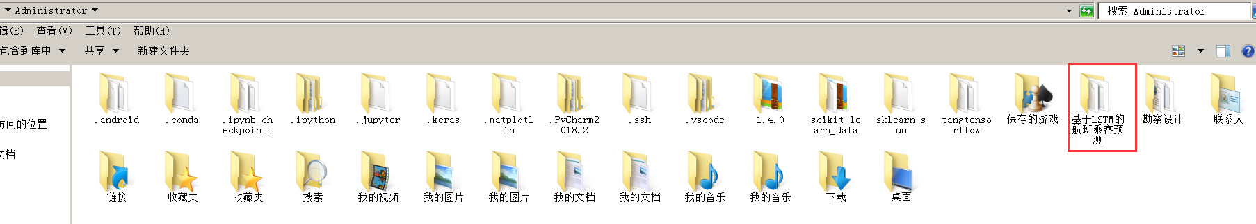
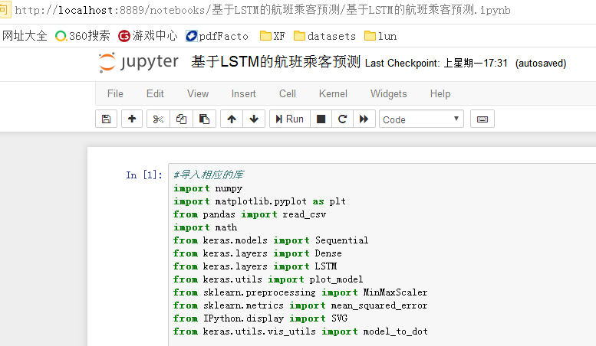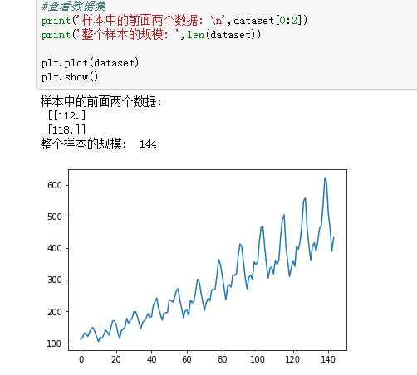
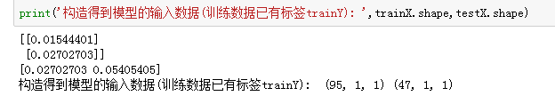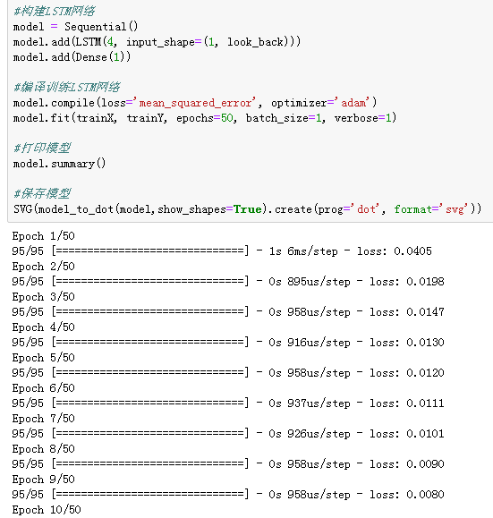
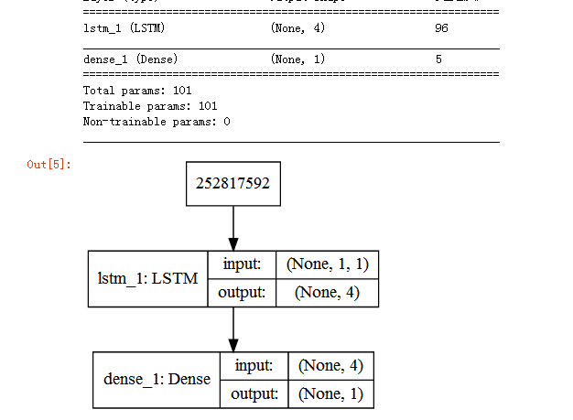
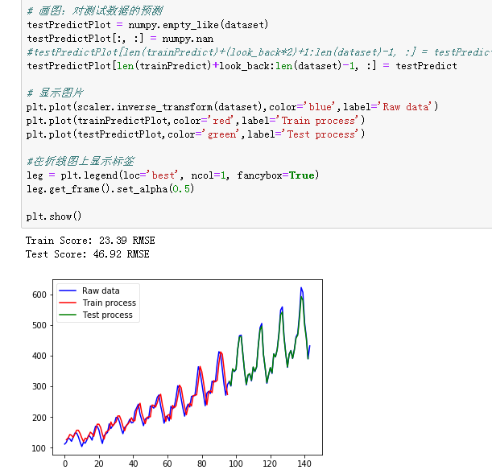

问题：
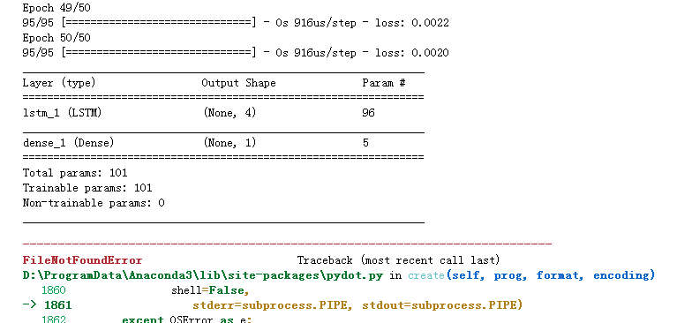

OSError: `pydot` failed to call GraphViz.Please install GraphViz (https://www.graphviz.org/) and ensure that its executables are in the $PATH.

安装GraphViz并配置环境变量，详见 Windows GraphViz安装与配置。

;D:\Program Files\MATLAB\R2014b\bin;D:\Program Files\MATLAB\R2014b\polyspace\bin;D:\Program Files\Git\cmd;D:\Program Files (x86)\Graphviz2.38\bin
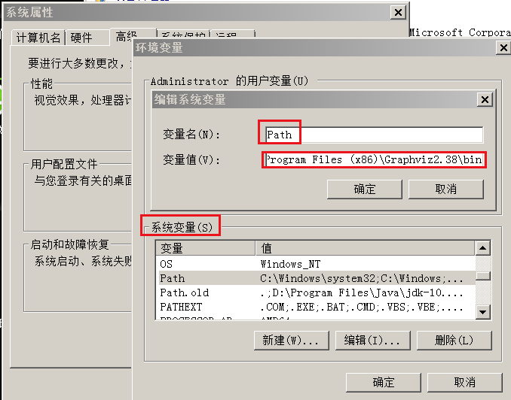

参考：
https://www.cnblogs.com/wushaogui/p/9051958.html

